Name of this app: A2DP Volume
Name of Sample app: Framework
Recognized pattern: AndroRAT_variety1
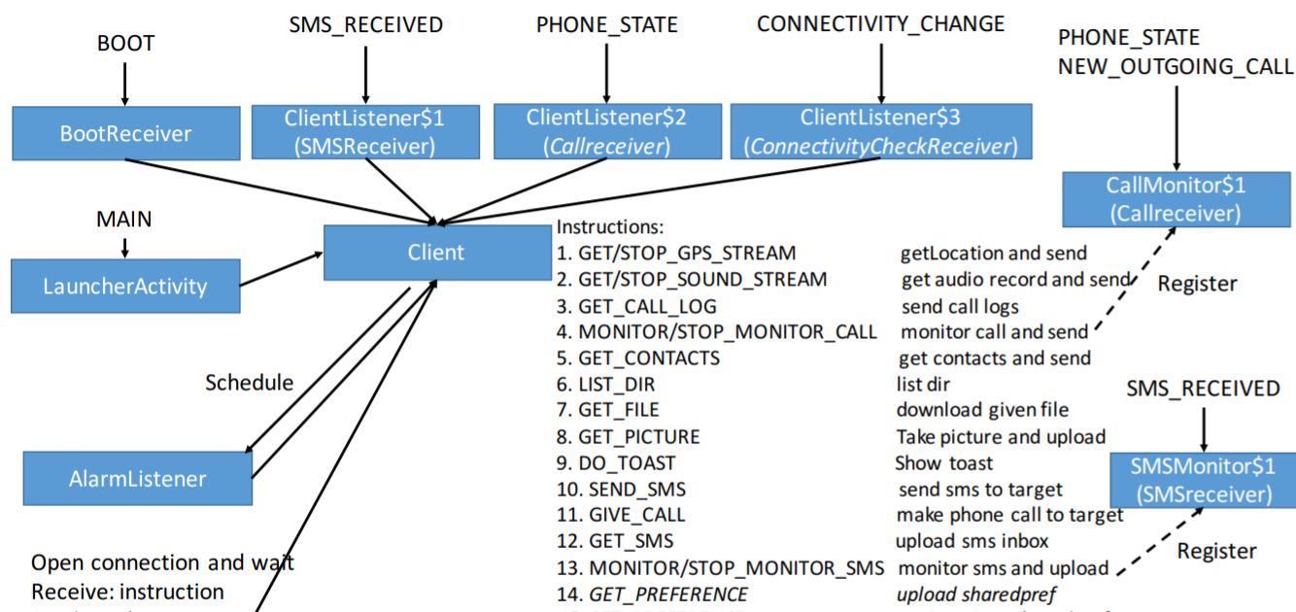
For functional modules:
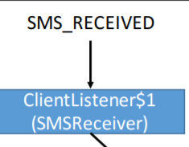

Corresponding to the key code in sample app:
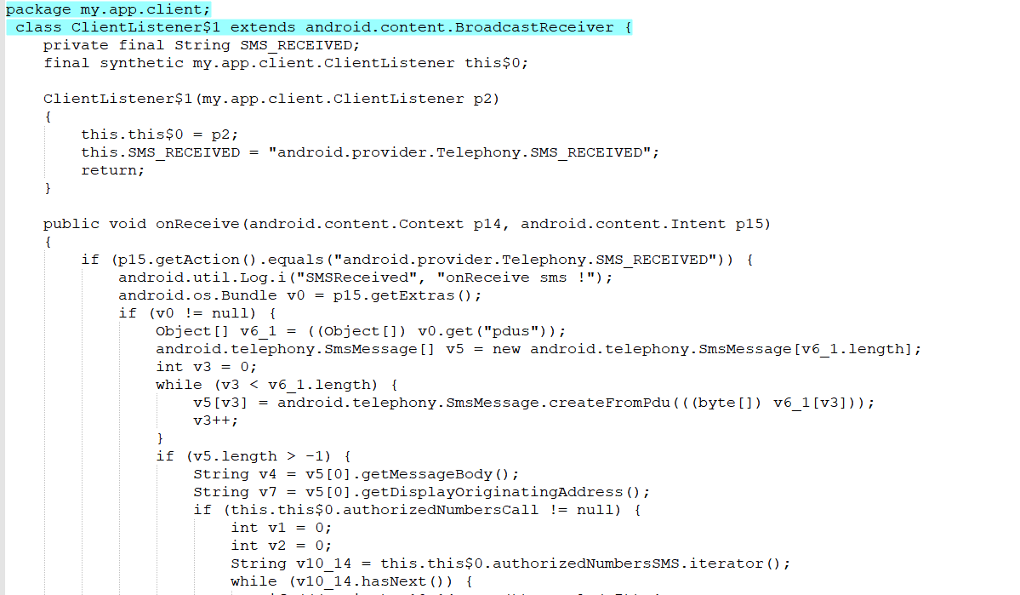

Corresponding to the key code in this app:
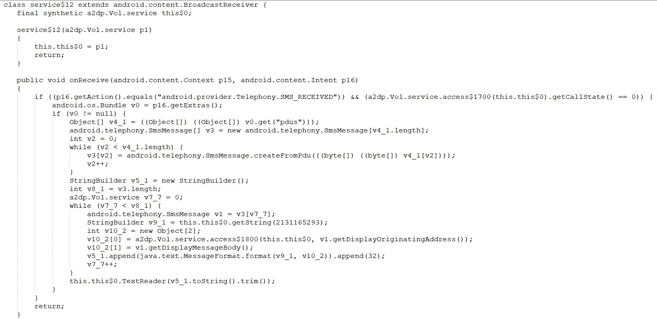
For functional modules:
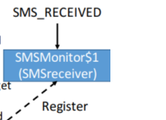
Corresponding to the key code in sample app:
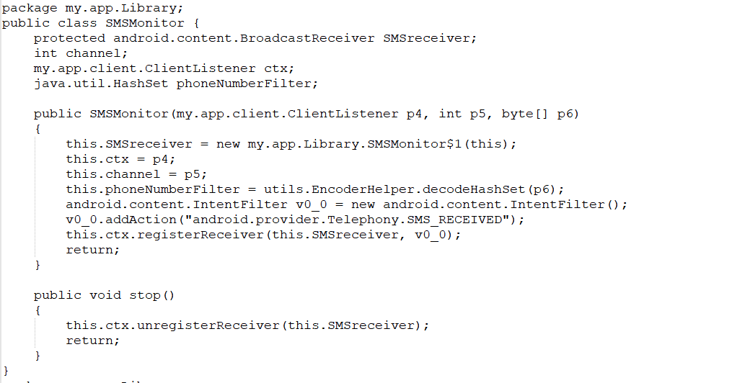
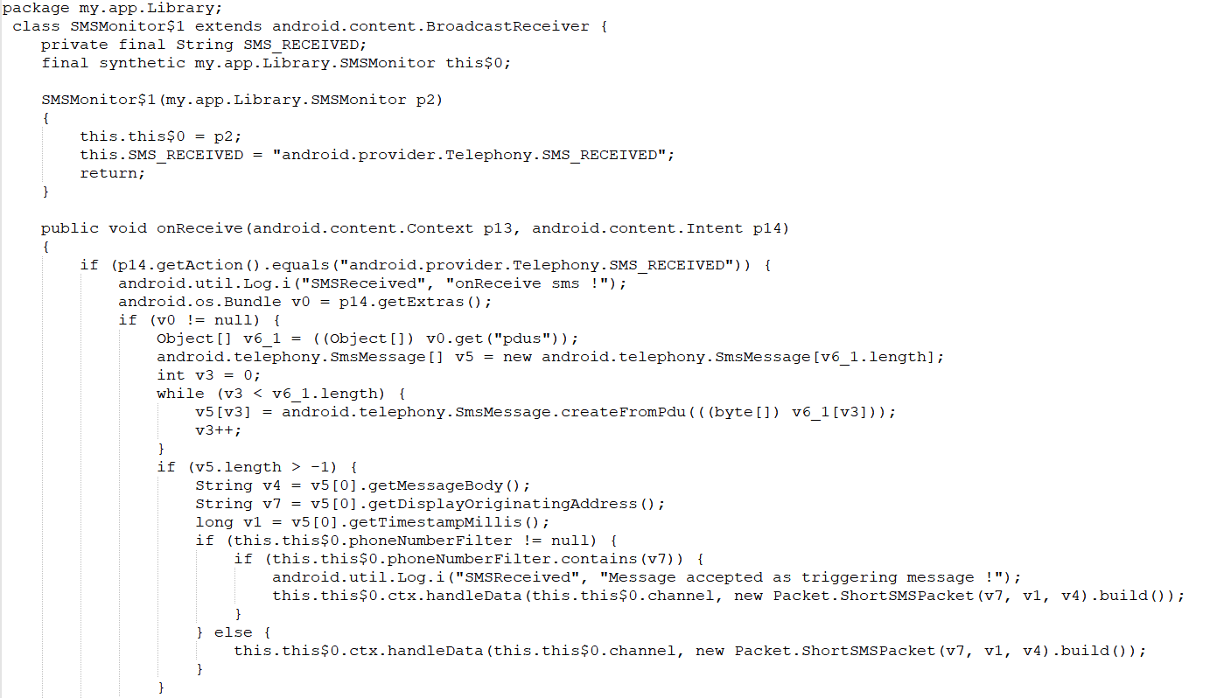
Corresponding to the key code in this app:
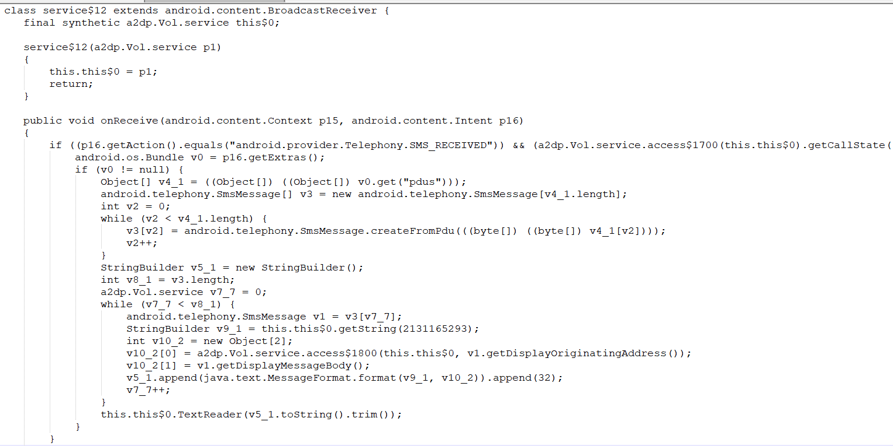
For function modules (i.e. acquiring GPS-related information):
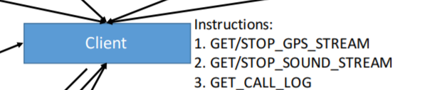
Corresponding to the key code in sample app:
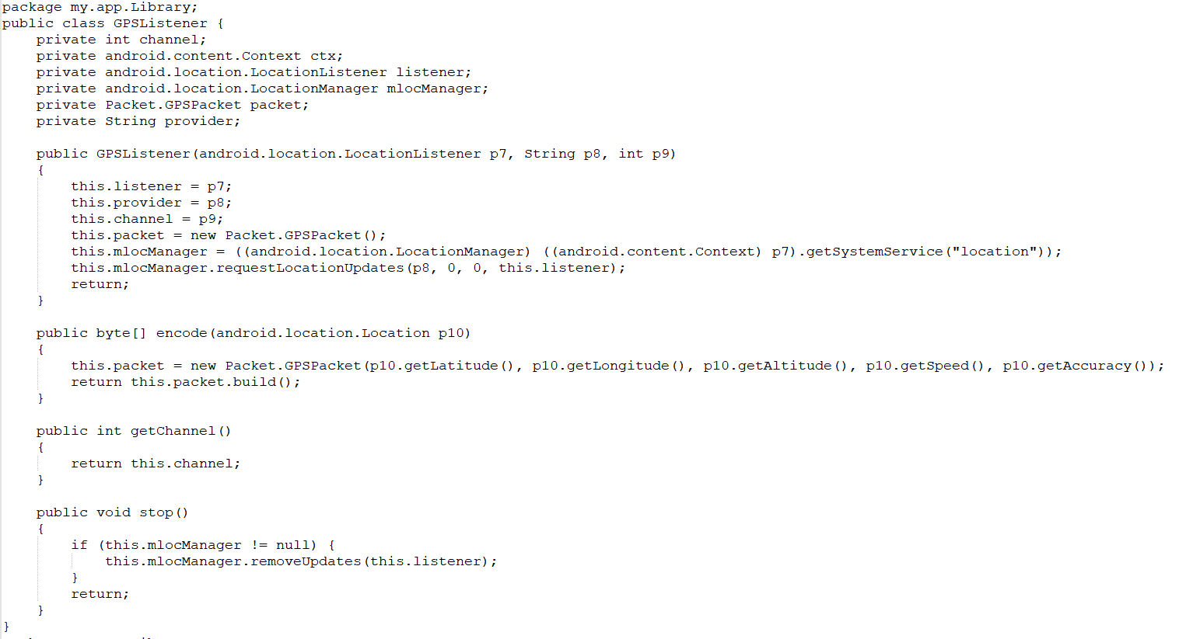

Corresponding to the key code in this app:
